**Recruitment CTF**

**Challenge Name:** Path to Entry

**Author:** Parnika Maskar

**Domain:** Forensics

**Challenge Description:**

Case : An undercover chef's house was raided. She was rumored to possess a secret key. Unfortunately, she escaped, but on searching her house we found her logged out laptop, drives and other belongings. On investigating the laptop, we found her Firefox browser information. Help us find the secret key.

**Solution :**

In the given file, open places.sqlite using sqlite browser. From there navigate to browse data then moz_places. Here in the search history a google drive link is provided.

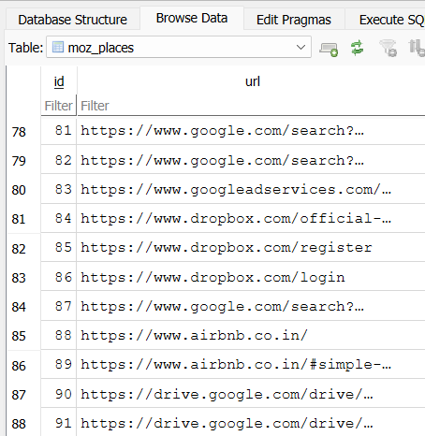

On opening the drive link we find a password protected file called as pizza.

To find the password:

Clone the github repository for firefox_decryption.

then in terminal: python firefox_decrypt.py <path_to_login.json>

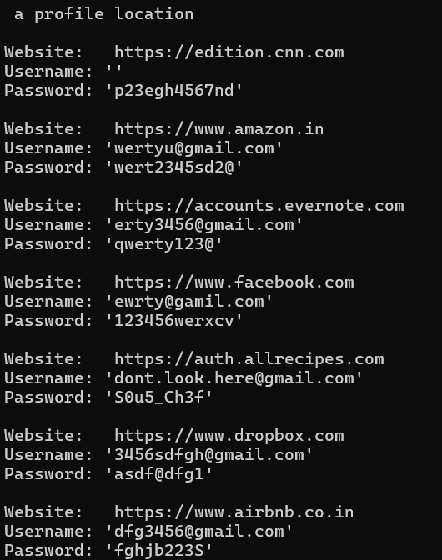



On entering the password, pdf file opens and flag is displayed

**FLAG = RecruitmentCTF{D1g1T4l3v1D3nce}**